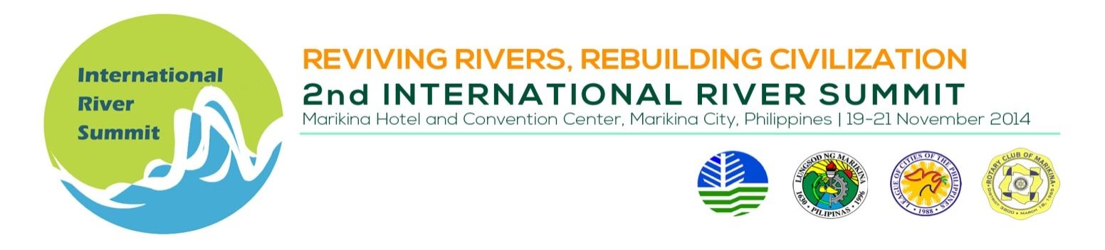
INDICATIVE PROGAMME

Thematic Session 8 : Role of River in Culture and Heritage

Venue : Session Rm. 2, 2nd Flr, Convention Center

Date/Time : November 20, 2014, 1:30 – 5:00 PM

Session Chair : Dir. Adelina M. Suemith, National Commission on Culture and the
Arts (NCCA)
Session Co-Chair : Dir. Catherine C. Agustin, Department of Tourism – National Capital
Region
Session Facilitator : Prof. Eric Zerrudo, Director, Center for Conservation of Cultural
Property and Environment in the Tropics, UST Graduate School,

TIME | TOPIC | SPEAKER
 | SESSION INTRODUCTION | Prof. Eric Zerrudo
 | Rivers and Philippine Civilizations | Dr. Lars Raymund C. Ubaldo, Associate Professor, De La Salle University Manila, Philippines
 | River Culture: Walking on Water, Evolving the Concept of Culture Riverscape | Prof. Eric Zerrudo,  Director, Center for Conservation of Cultural Property and Environment in the Tropics, University of Santo Tomas Graduate School,
 | BREAK
 | Fluvial processions: The case of Penafrancia | Hon. John Bongat,  Mayor, Naga City / Mr. Wilfredo Prilles, Jr., Department Head, City Planning and Development Office, Naga City
 | Totally Thames Festival London | Mr. Adrian Evans,  Festival Director & Pageant Master, Totally Thames London, United Kingdom of Great Britain and Northern Ireland
 | Preserving the built environment of Iloilo River: Focus on Heritage Conservation

